Our Mission:
To serve individuals with developmental disabilities by the means of comprehensive care and individualized support services that will maximize their independence, empowerment, personal growth, and quality of life.

Provide care and support services to our clients with various healthcare needs in the areas of personal care, behavioral support, recreational and employment services.

We are looking for kindhearted staff willing to go above and beyond in supporting our clients.

*Our company is an equal opportunity employer and does not discriminate on the basis of race, religion, color, national origin, age, sex, gender, gender identity, gender expression, genetic information, disability or any other characteristic protected by law.*

Looking for a job?

We’re hiring for:
- Direct Support Professionals
- Residential Program Supervisors
- HR Recruiter
- Part-Time registered Nurse
- Quality Assurance Specialist
- Housing Specialist

Caring with peace of mind
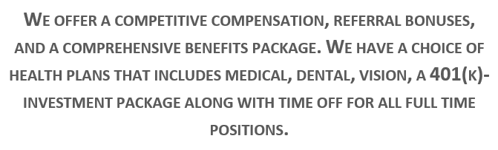

Apply online today! http://www.apluscarellc.com/employment-opportunities
Call (732) 570 – 9808 or email compliance@apluscarellc.com with questions!

